A Wide Area Situational Awareness Model for Sequential Restoration of Critical Inverter-Dominated Smart Grids

**Chaudhry Talha Hassan1, Muhammad Shamaas2, Tariq Mahmood Jadoon3**

1, 2, 3Department of Electrical Engineering, Lahore University of Management Sciences, Lahore 54792, Pakistan

118060043@lums.edu.pk, 218100217@lums.edu.pk, 3jadoon@lums.edu.pk

**Abstract** –*After a major blackout, a self-sufficient smart grid can restore healthy nodes by forming microgrids around black start DGs. These microgrids grow gradually in time until all the critical loads are restored. Constellation of faults and radiality constraints determine the load pick-up order and boundaries of microgrids. The microgrid restoration optimization model can only approximate the electrical power network equations. The unpredictable transient response of load switching and power ramping can cause unwanted disturbance to all connected nodes. Hence the real-time transient results of electrical power flow are used to reinforce dynamic stability after every restoration stage. The sequential restoration process is formulated as a mixed-integer second order cone program (MISOCP) optimization problem. The generated network traffic for wide area monitoring is simulated in NS-3, whereas the power system simulation is performed in GridLAB-D. The approach is validated over a modified IEEE-123 node test feeder and the results are presented to demonstrate the efficacy of the framework for multiple fault scenarios.*

**Keywords:**Wide area situational awareness (WASA), mixed-integer second order cone programming (MISOCP), inverter-based distributed generator (IBDG), energy storage system (ESS)

# Nomenclature

Sets

Set of bus blocks.

Set of generators with black start capability.

Set of generators.

Set of inverter-based generators.

Set of distribution lines.

Set of generators without black start capability.

Set of non-switchable lines.

Set of phases.

Set of synchronous generators.

Set of switchable lines.

Set of loads.

Indices

Index of bus block.

Index of generator.

Index of bus.

Index of distribution line.

Index of microgrid.

Index of phase.

Index of time step.

Index of load.

Parameters

Multiplier for dynamic stability factor equation.

P-⍵ and Q-V droop gains.

Limit for maximum allowable frequency drop.

Measured maximum transient frequency drop.

Limit for maximum allowable voltage drop.

Measured maximum transient voltage drop.

Nominal steady state frequency.

Minimum allowable frequency.

⨉ matrix of ones.

Big-M number.

3⨉3 Phase matrix of line .

Maximum output real power limit of generator .

Maximum output real power limit of distribution line .

Maximum output reactive power limit of generator .

Maximum output reactive power limit of distribution line .

3⨉3 resistance matrix of line .

Length of rolling horizon.

3⨉1 squared three-phase voltage magnitude matrix of bus .

Maximum squared voltage magnitude limit of bus .

Minimum squared voltage magnitude limit of bus .

Nominal phase to ground rms bus voltage.

Phase to ground rms voltage of bus .

Priority weight for load of bus .

3⨉3 Reactance matrix of line .

3⨉3 Impedance matrix of line .

Variables

Maximum limit for restored load of microgrid at stage .

Limit of maximum restored load for microgrid at stage .

Active power flow of line , phase at stage .

Active power output of generator , phase at stage .

Active power demand of load , phase at stage .

Reactive power flow of line , phase at stage .

Reactive power output of generator , phase at stage .

Reactive power demand of load , phase at stage .

Stability factor of microgrid at stage .

Binary energization status of bus .

Binary energization status of line .

Binary energization status of load .

Binary energization status of generator .

Binary energization status of bus block .

# Introduction

Advancement in smart grid technologies has called for a higher reliability of service to the consumers. Although faults and outages are inevitable, service must be restored back to normal in case of a blackout. During such an unexpected emergency, the generation capacity and energy reserves must be carefully utilized to recover critical loads. An effective method for emergency service restoration is the sectionalization of power network into microgrids [xyz14]. These islanded power systems coordinate all the decisions for self-healing. Hence power restoration can be achieved in a decentralized manner [xyz11].

Bulk power distribution networks have very few switchable lines and loads [xyz18]. The network can often be sectioned into large bus blocks [xyz1]. Switching many inductive loads at once can result in severe frequency and voltage oscillations. This makes the service restoration process very hasty and aggressive. Voltage and current spikes can get multiplied greatly when they pass through distribution transformers. Such hostility can cause severe damage to inverters and energy storage devices [xyz22].

Modern smart grids can have an extensive range of loads, switches and auxiliary equipment. Multiple practical limits must be considered for sequential switching of manual and remote-controlled switches [xyz1]. The operating time of a switch can be impacted by the type of the switch, the location of the switch [xyz4] and the constraints of communication channel [xyz16]. Coordination of switches is also important to prevent overloading of power generators. All the changes in network topology must be considered to make feasible microgrids having radial structure and sufficient generation capacity [xyz16].

Microgrid restoration can be very challenging for inverter-dominated smart grids because these networks suffer from poor dynamic stability [xyz12]. Operating multiple inverter-based generators can be difficult if they have dissimilar droop characteristics and ramp limitations. The unpredictable nature of non-linear semiconductor devices makes inverters especially susceptible to damage during electrical overloads, voltage fluctuations and short circuit faults [xyz23]. Inverters can face commutation failure or permanent damage if the maximum limits for safe operation are breached [xyz19]. Optimal power exchange must be ensured to prevent overstressing of IBDGs [xyz11].

The most important issue of restoring three-phase unbalanced power distributions networks is overheating of generators due to current unbalance, excessive ramping, frequency drop and voltage oscillations [xyz3] [xyz21]. The health of energy storage systems must also be monitored for inverter-based generators. A strategic charging/ discharging strategy can be formulated to maintain SOC within a safe limit [xyz2]. To prevent damage to generators, sufficient spinning reserve must be maintained to compensate for errors in load forecast [xyz14]. The microgrid frequency response rate can be approximated based on the total generation capacity of restored generators [xyz7] [xyz10]. By limiting the ramp rate of synchronous generators, the RoCoF can be reduced to a reasonable value [xyz2] [xyz19] [xyz20]. Such approximation methods can effectively constrain the maximum frequency drop by limiting the maximum recovered load in each stage [xyz21]. However, these techniques cannot be applied for inverter-based generators with low-inertia and unbalanced loading [xyz23] [xyz12]. The frequency response of inverters is highly unpredictable. Static as well as dynamic constraints for voltage, current and frequency must be imposed to prevent damage of sensitive electronic equipment [xyz5] [xyz8] [xyz12] [xyz18] [xyz22].

Power flow analysis is a useful tool for a variety of power system applications. Several models and algorithms have been developed for optimal power flow analysis. This convex problem can be simplified through several approximations and relaxations. Constant current and constant impedance loads can be represented using linearized power flow models [xyz3]. Shunt capacitors, voltage regulators and distribution transformers can be represented using linear constraints. Overloading of transformers and transmission lines can be prevented using quadratic or approximate, polygon-based linearized constraints [xyz2] [xyz3]. The problem of power flow in unbalanced multi-phase radial network can be solved using semi-definite programming. Conic and quadratic optimization can be used for transmission system planning and distribution system reconfiguration. Mixed-integer models with quadratic, conic and semi-definite optimization can be used for power loss analysis [xyz10]. Load flow problems of radially distributed networks can be modeled by convex or conic optimization programs [xyz10]. Although complex optimization problems can accurately model the steady state behavior of these power system elements, their transient behavior cannot be predicted. An active wide-area monitoring system is required to ensure safe operation during switching operations and power shuffling [xyz18].

Centralized approach for load restoration considers it as a classical optimization problem with an objective to maximize critical load pickup incorporating associated constraints. The restoration process can be optimized through various techniques. The most powerful methods for solving this optimization problem include mixed-integer linear programming, dynamic programming, multi-agent systems [xyz16] and heuristic algorithms [xyz6]. Although it can lead to sub-optimal solutions, linear programming has the lowest computation cost and the highest rate of convergence compared to all other methods [xyz1]. For fault restoration of smart grids involving renewable energy sources, energy generation cannot be accurately forecasted [xyz6] [xyz10] [xyz11]. The load diversity can also be highly unpredictable after a blackout [xyz2] [xyz16]. Hence, a combination of stochastic optimization and mixed-integer linear programming is preferred because this can provide approximate solutions with high convergence rate and computation speed [xyz2] [xyz6] [xyz8] [xyz11].

The role of synchronous generator as a black-start capable DG has not been studied in detail for service restoration problems. Besides improving electrical stability, high inertia diesel generators can act as reliable power sources unlike renewable energy generators [xyz15]. There are new opportunities to consider rather obsolete synchronous generators or back-up generators as a source of providing black start capability [xyz19]. Constraints like ramp up/ down time, inertial capacities of prime-movers and its excitation are important for their operation. The utility of BUGs can be increased to harness power and improve microgrid stability.

Standardization of smart grid communication technologies has offered new opportunities for improved protection and control of green smart grids. With the increasing installation of remote-controlled smart switches, tie-lines, isolators and distributed energy resources there is a growing need for improving this communication layer in cyber-physical distribution systems. Power quality monitoring modules integrated with high frequency transceivers allow real time monitoring of transient fault records with millisecond precision. Active management of smart grids is now possible with improved processing power and fast networking solutions.

# Motivation And Contribution

The inverter-dominated distribution system reconfiguration problem is a complex combinatorial problem due to non-linear power flow equations and unpredictable generation of renewable energy sources. A highly complicated optimization scheme is needed to incorporate all the intricacies of the analog and digital components. The optimization model can only approximate the electrical power network equations; hence the results of electrical power flow must be used to reinforce dynamic stability after every restoration stage

An intelligent control system must be well informed about the situation of all the important subsystems. The switching decisions must be based on real-time data obtained from distributed field devices. Hence, an active management system was designed to sense and optimally control all the distributed subsystems.

For effective sequential microgrid restoration, the effect of past decisions must impact the solution of the next optimization stage. After each restoration stage, a scan of the entire network was acquired to judge the electrical stability of the recovered region. If the network was qualified as unstable, further load restoration was delayed. The real-time feedback allowed the central controller to carry out time-sensitive optimization tasks.

A significant contribution of this work is towards a cyber-physical implementation of a resilient distribution system. The switching sequence and the load restoration decisions determined by solving the MISOCP optimization problem were implemented over a distributed control framework. The different subsystems operated in a cooperative manner with two-way negotiations to exchange information and control signals across the network.

To make the healing process smooth and efficient, all the loads, generators and switches could be controlled remotely. Based on the communication requirements, network traffic was simulated in NS-3 to determine latencies and QoS of the network. The resulting reconfiguration commands and inter-switch operating delays were finally simulated in GridLAB-D to determine the transient response. This output provided feedback for the next stage of the rolling horizon restoration optimization problem.

This research aims to achieve the following goals:

1. Develop a decentralized control architecture for restoration of microgrids. The utility operator was provided with all the relevant information for controlling distributed generators, reconfiguration of distribution network and forecasting load demand. The autonomous central controller performed MISOCP optimization for all supervisory tasks. Besides routine tasks like controlling distributed generators, demand response and Volt-Var regulation; it also performed special tasks like fault detection and network reconfiguration. Based on the wide area situational data, it distributed control commands to the different microgrid controllers. These autonomous controllers were responsible for coordinating the aggregated operation of distributed local controllers within their microgrid.

2. Execute information exchange to coordinate the control and protection of microgrids during sequential service restoration. The microgrid controller was responsible for monitoring all the widespread nodes. It aggregated the status information and distributed the control commands of all the subsystems. The hierarchical structure for data exchange was implemented using a fast and reliable communication system in NS-3.

3. Quantify the aggression afflicted during each microgrid restoration stage to provide feedback for microgrid protection system. To ensure dynamic stability, a rolling horizon optimization framework was implemented in the central controller. After every switching action, the maximum deviation of voltage, current and frequency was sensed at each node and line. Before each restoration stage, all the recovered nodes were checked for electrical safety to ensure that they were indeed healthy. GridLAB-D simulation transient fault records were used to calculate the microgrid disturbance factor. This was used to restrain the sequential restoration algorithm so that the next stage could be improved.

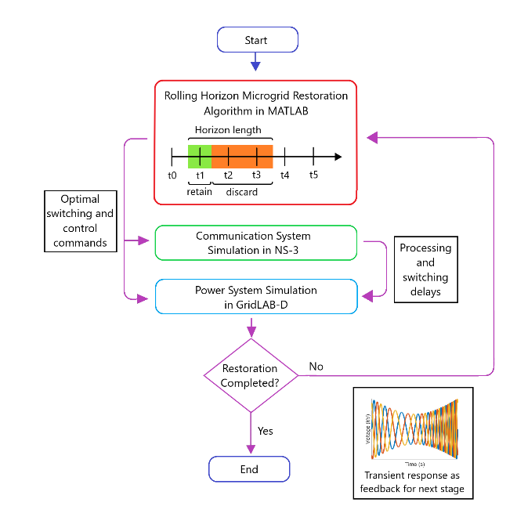

Figure 1: Three-level sequential microgrid restoration model.

# Formulation Of Optimization Problem

The service restoration system executed a self-healing algorithm. The initial decision for network reconfiguration was based on the fault location input. The unhealthy region was isolated immediately. Afterwards, iterative microgrid formation started.

The healthy bus blocks were enumerated and grouped based on geographic proximity. The bus blocks that could be connected via switchable lines were assigned a microgrid. This determined the boundaries of the microgrids.

For each microgrid, a root node was assigned, which would be solely responsible for communicating all the status and control information with the utility operation center. The high rank node had a diesel generator with black start capability. Iterative depth first search algorithm was used to rank bus blocks in order of energization. The bus blocks closer to root node would be energized earlier.

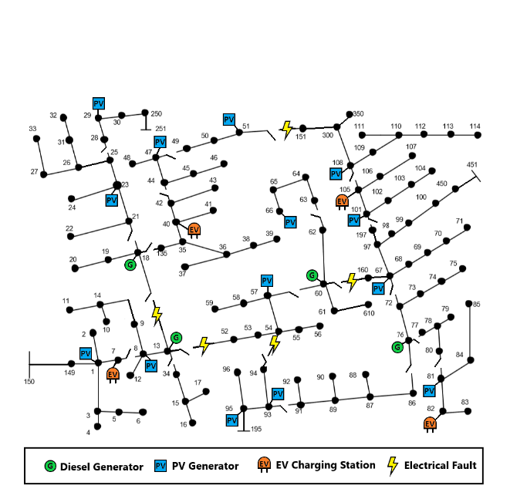

Figure 2: Damaged IEEE 123 bus distribution network

Operational planning determined the optimal switching pattern for demand response management, network reconfiguration, dynamic stability, fault level management and Volt-Var control. Load management was based on load forecast, weather forecast, unit availability and energy storage capacity.

The objective function (1) aimed to maximize the total recovered loads over a rolling horizon . The priorities of the loads were assigned randomly.

1. Nodal power balance constraints: Constraints (1)-(2) define the nodal balance of active and reactive power for each phase. Linearized DistFlow equations are used to approximate the electrical power flow [xyz11]. They state that the generated power must be equal to the sum of load demand, transmitted power and line losses.

2. Transmission line constraints: Constraints (3)-(5) define the limits for transmission line active and reactive power losses. The line losses are determined by the loss factor of the line and the apparent power flow:

Constraints (5)-(6) define the transmission line active and reactive power flow limits. Constraints (7)-(8) state the conditions for energization of switchable lines. Constraint (9) implies that non-switchable lines are energized whenever the corresponding bus is energized.

3. Generation constraints: Constraint (7) defines the active and reactive power generation limits for generators. Constraint (8) states that the power of diesel generators cannot be negative. It does not hold for generators with ESS. Constraints (9)-(10) state that a generator without black start capability can be started only if its associated bus is energized, and that it cannot be turned off after it has been started. Constraints (11)-(12) define the output active and reactive power ramp rate for the distributed generators (PV inverters, PHEV inverters and Diesel Generators).

4. Load constraints: Constraints (14) states that a load is energized whenever its corresponding bus has been energized. Constraint (15) states that once a load has started operation, it cannot be stopped.

5. Nodal voltage constraints: Constraints (11)-(12) define the voltage difference between the end nodes of a transmission line. The Big-M notation is used to ensure that these constraints are active only when the line is energized. Constraint (13) ensures that the bus voltage is constrained within predefined limits.

6. Bus block switching: The healthy bus blocks were enumerated and grouped based on geographic proximity. The reduced network contained a set of bus blocks that were connected by a set of switchable lines:

Constraint (16) ensures that all the buses in a bus block get energized simultaneously. Constraint (17) ensures that a switchable line cannot be closed if both its end blocks are already energized. This is required for maintaining radial tree topology during microgrid restoration. Constraint (18) states that a bus block can only be switched on by one of the connected switchable lines. Constraint (19) makes sure that switchable lines are energized before energization of connected bus block. Finally, Constraint (20) implies that a switchable line can be energized only if at least one of the connected bus blocks is already energized.

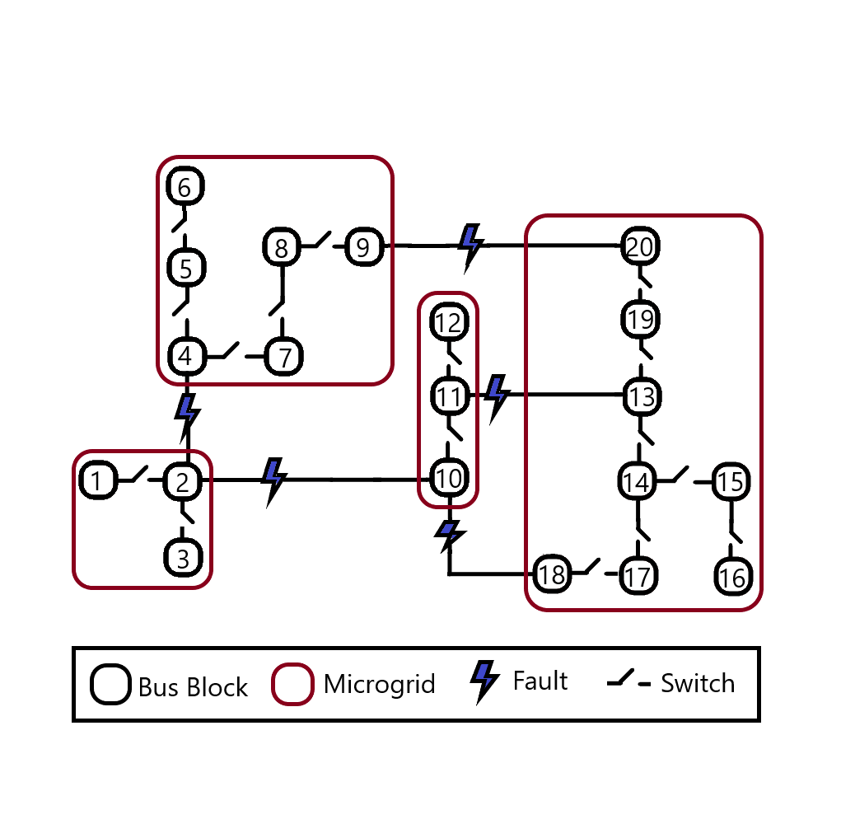

Figure 3: Reduced IEEE-123 bus power network showing bus blocks and microgrids.

7. Dynamic constraints: After the control commands of a stage were executed, the maximum value for frequency, voltage and current transient were recorded for each restored node. This was translated into a numerical parameter for expressing the stability of the microgrid. Equation (22) presents the formula for calculating the microgrid disturbance factor. The ultimate use of this factor was to restrain the amount of restored load in the next stage of rolling horizon optimization, as expressed in equation (21) and (23). These transient nodal voltage constraints, nodal frequency constraints and line current constraints reinforce dynamic stability of the healing microgrid.

# Communication System

A three-level communication network was designed in NS-3 to simulate the coordination between the utility operation center, microgrid controllers and IEDs.

The Wide Area Network provided remote access of microgrids to the central management system via long range, high-capacity WiMAX links. NS-3 provides a realistic implementation of the IEEE-802.16 standard using Wireless MAN-OFDM physical layer, uplink and downlink schedulers, IP packet classifier for the convergence sub-layer, and support for multicast traffic. A base station was installed to serve the subscriber stations installed at the central controller and the microgrid controller nodes. The point-to-multipoint telecommunication network enabled pervasive control of the entire distribution system for time-sensitive tasks like maintaining electrical stability.

The Field Area Network used existing power lines to transmit control and status signals. Each power line communication device was supplemented with a data concentrator for communication with the widespread smart meters. Distributed generators were controlled via Programmable logic controllers integrated with SCADA modems. The transmission line channels also conveyed switching commands for capacitor banks, load controllers and circuit breakers. To ensure dynamic stability throughout the restoration, status signals of all the nodes were relayed periodically to the central controller.

The Home Area Network connected load controllers and sensors via an Ethernet-based AMI. This enabled coordination of a large number of distributed IEDs. These devices continuously collected information from power meters, transducers and field components for supervision. For fast and reliable communication, IPv4 protocol was implemented in the network layer and UDP protocol was implemented in the transport layer. The IEDs were complemented with data concentrators for integration; and remote terminal units for communication channel interfacing. The network interface module implemented distributed network protocol for physical interface conversion. The pervasive communication system enabled continuous scanning of operational data for greater control and flexibility. However, the extensive monitoring required enhanced communication channel utilization. The repeated synchronization also introduced substantial computation overhead.

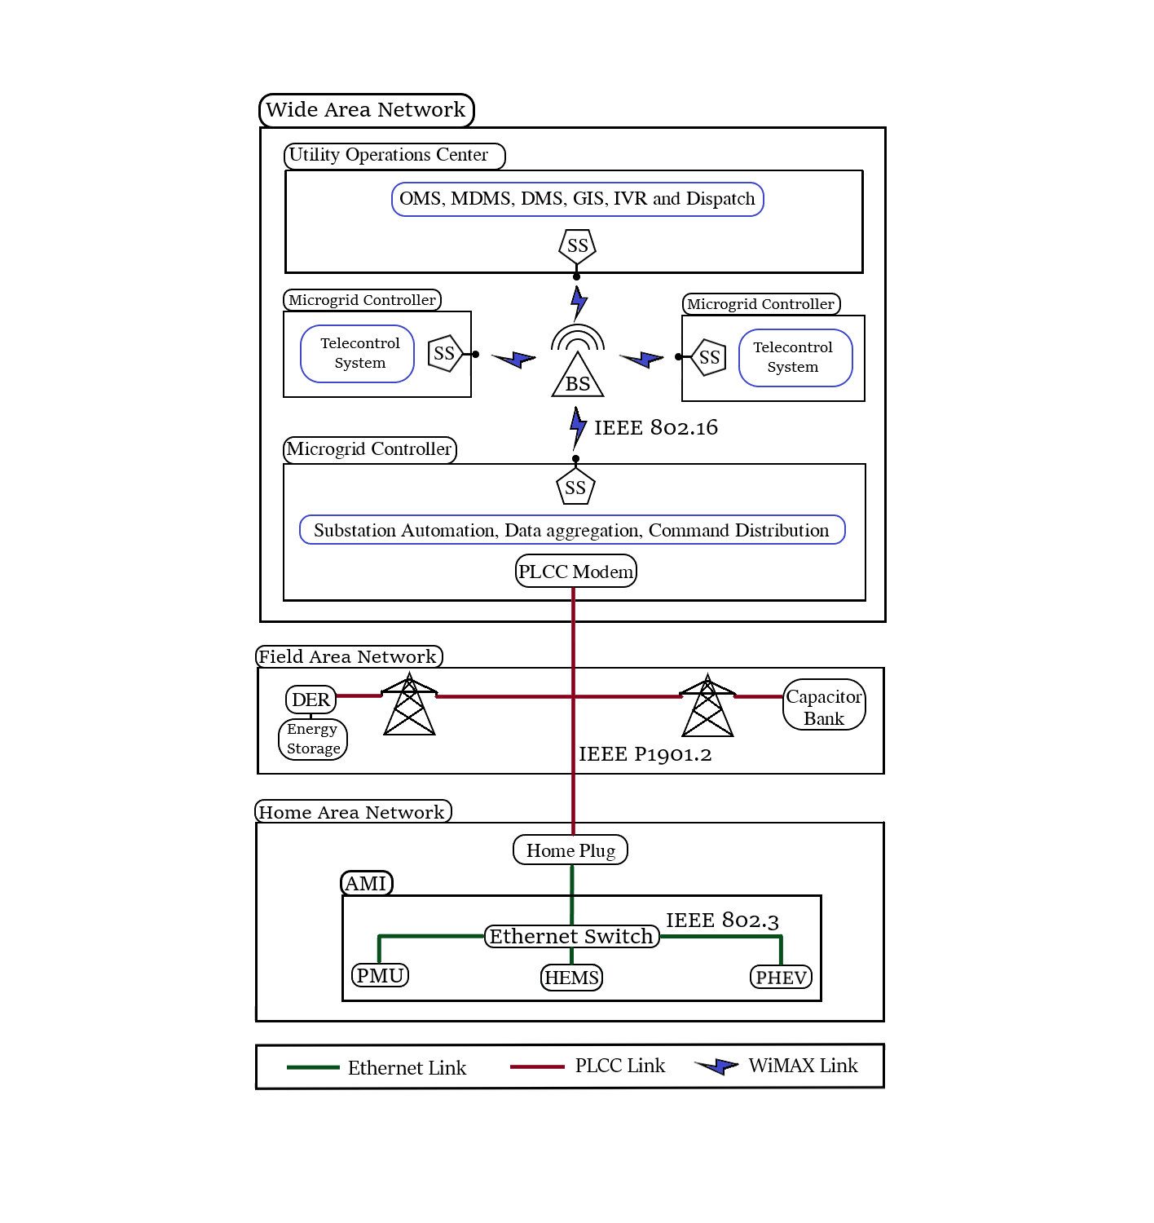

Figure 4: Three-tier communication system for wide area situational awareness model.

# Power System Simulation

IEEE 123-bus modified feeder was simulated in GridLAB-D to verify the MISOCP optimization results. The simulated system was approximated by linear approximations in the optimization problem.

The simulator uses Newton-Raphson method to solve the power flow equations (24)-(26) iteratively until the solution converges.

where is the real power injection at node , is the reactive power injection at node , is the admittance of the line between nodes and and is the voltage at node .

Three different types of time variant loads were modeled in GridLAB-D: constant current loads, constant power loads and constant impedance loads.

The diagram of the GGOV diesel generator governor is shown in the Figure 5.

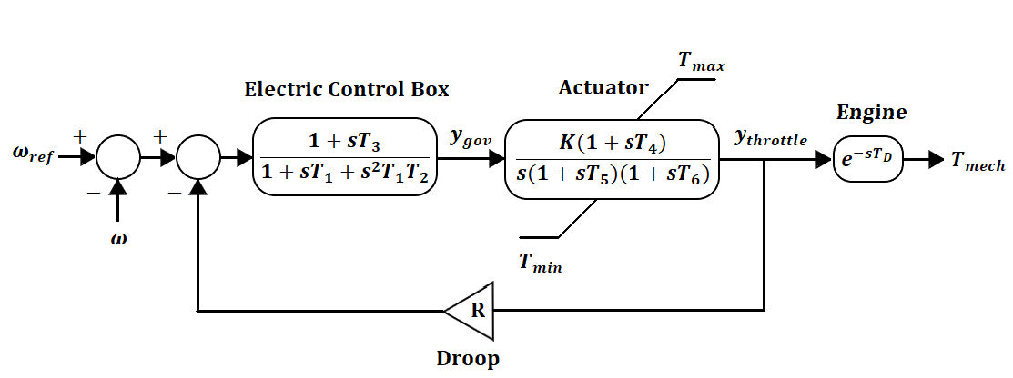

Figure 5: Diagram of GGOV diesel generator governor.

The diagram of the droop mode voltage source inverter [xyz23] is shown in the Figure 6.

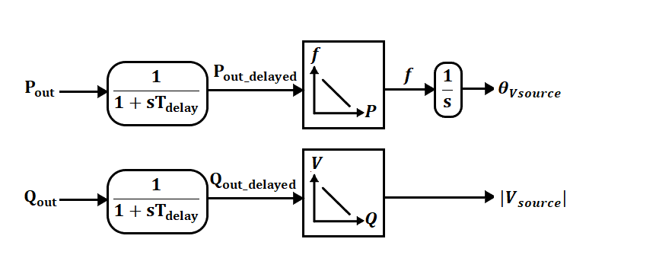

Figure 6: Diagram of droop mode voltage source inverter.

The microgrid frequency response can be approximated by the first-order swing equation [xyz19]:

where is the frequency deviation, is the system inertia, is the load damping rate, is the increased output from synchronous generators, is the increased output from inverter-based generators and is the generation loss.

# Simulation Results

Three different WiMAX uplink schedulers are supported in NS-3: priority based First Come First Serve scheduler (FCFS), Migration Based Quality of Service scheduler (MBQoS) and Real Time Polling Service scheduler (RTPS). Five different service flows can be implemented including Unsolicited Grant Service (UGS), Real Time Polling Service (rtPS), Non Real Time Polling Service (nrtPS) and Best Effort (BE).



Figure 7: Comparison of throughput for three WiMAX schedulers.

The simulated load demand was intentionally different from the predicted demand. This was done to analyze the effects of forecast errors on the rolling horizon optimization framework.

Case1: Base case

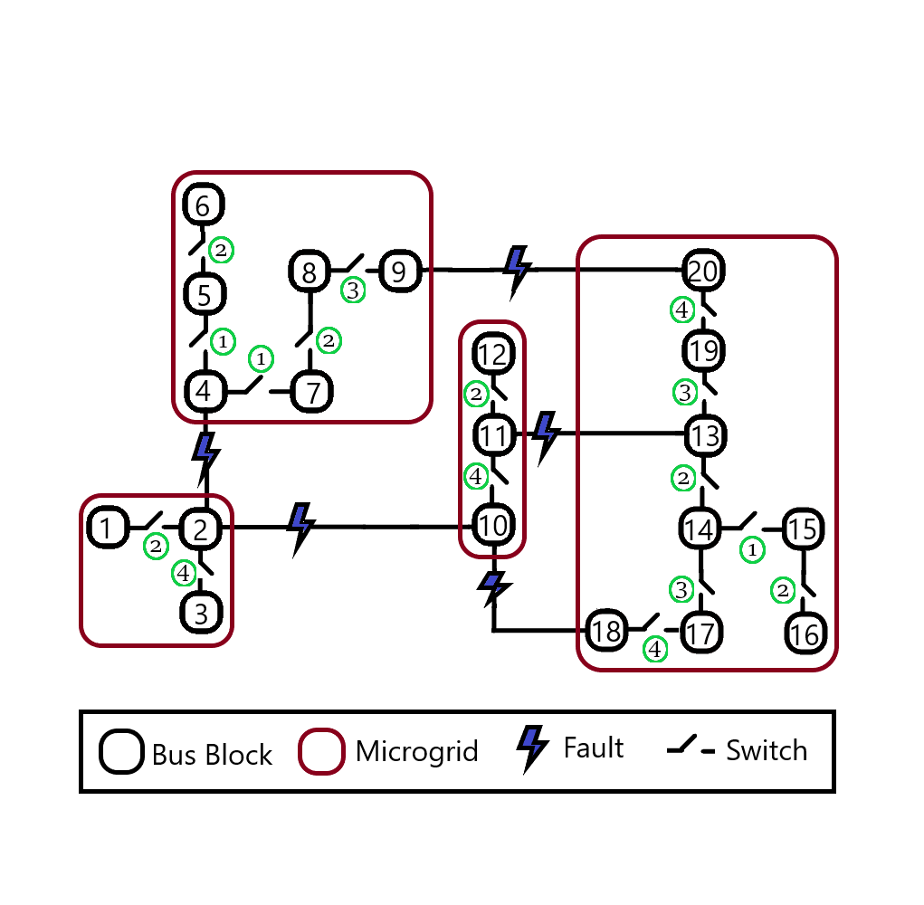



Figure 8: Base case without feedback.



Figure 9: Base case voltage node 18.



Figure 10: Base case phase current 18_35 line.



Figure 11: Base case frequency node 18.

The simulation was repeated to evaluate the effect of dynamic constraints.

Case2: df=0.25 Hz, dV=120 V, dI=10 A.

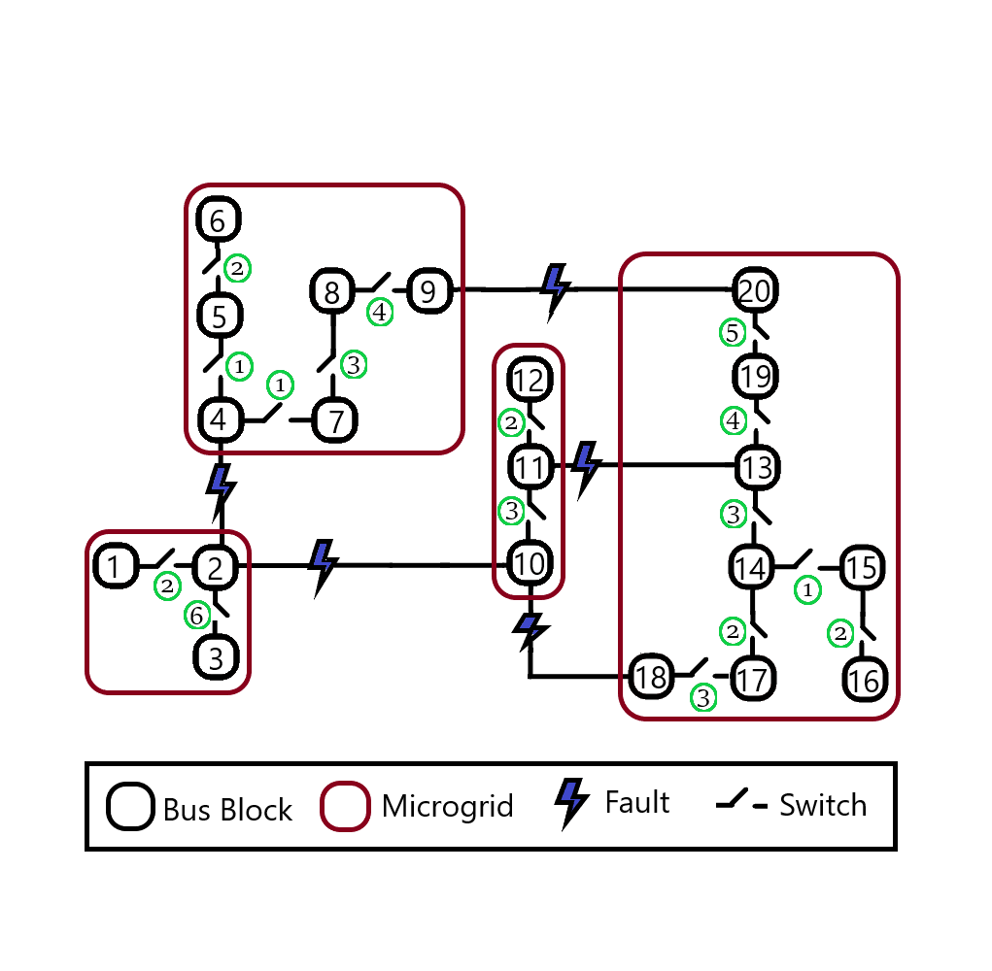

Case3: df=0.10 Hz, dV=60 V, dI=5 A.

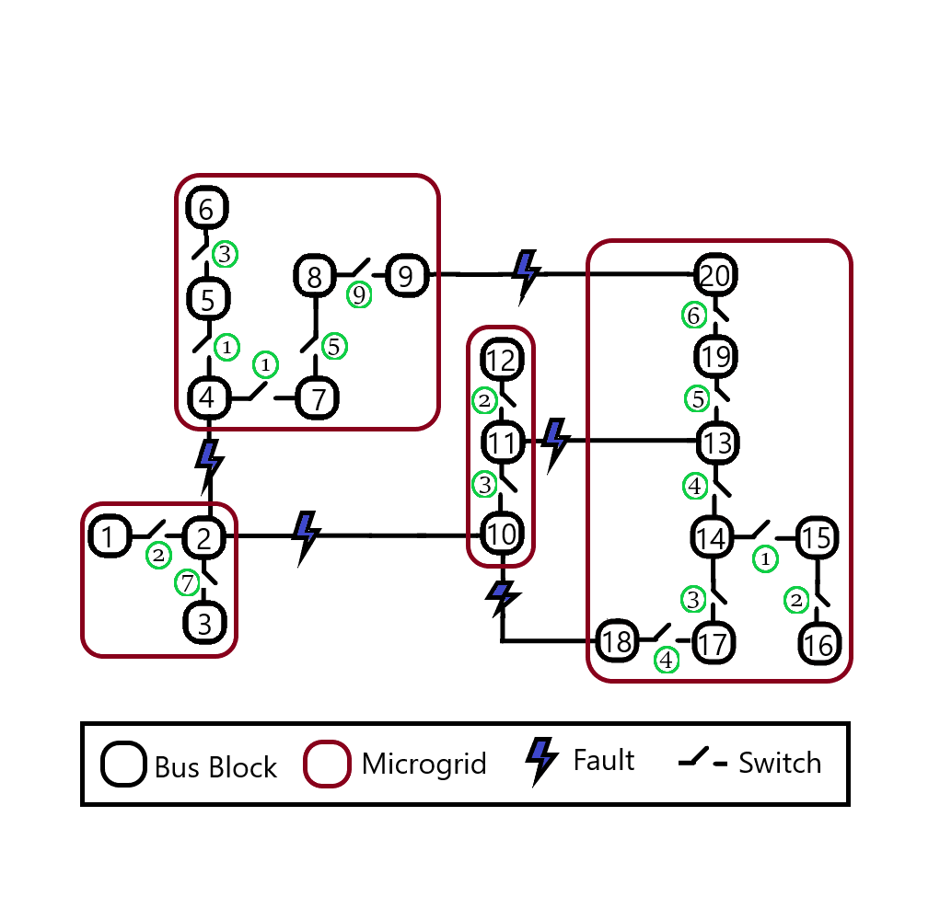

# Discussion

T.

|  |  |  |  |
| --- | --- | --- | --- |
| Restoration Stage | Case 1 | Case 2 | Case 3 |
| 1 | 2, 4, 5, 7, 11, 14, 15 | 2, 4, 5, 7, 11, 14, 15 | 2, 4, 5, 7, 11, 14, 15 |
| 2 | 6, 12, 8, 16, 1, 13 | 6, 12, 16, 1, 17 | 12, 16, 1 |
| 3 | 9, 17, 19 | 18, 8, 10, 13 | 6, 17, 10 |
| 4 | 3, 18, 20, 10 | 9, 19 | 18, 13 |
| 5 | - | 20 | 8, 19 |
| 6 | - | 3 | 9, 20 |
| 7 | - | - | 3 |



Figure 12: Comparison of load restoration in three cases.

# Conclusion

A.

# References

[xyz1] A. Arif, B. Cui and Z. Wang, "Switching device-cognizant sequential distribution system restoration", IEEE Transactions on Power Systems, vol. 37, no. 1, pp. 317-329, Jan. 2022.

[xyz2] B. Chen, C. Chen, J. Wang and K. L. Butler-Purry, "Multi-time step service restoration for advanced distribution systems and microgrids", IEEE Transactions on Smart Grid, vol. 9, no. 6, pp. 6793-6805, Nov. 2018.

[xyz3] B. Chen, C. Chen, J. Wang and K. L. Butler-Purry, "Sequential service restoration for unbalanced distribution systems and microgrids", IEEE Transactions on Power Systems, vol. 33, no. 2, pp. 1507-1520, March 2018.

[xyz4] B. Chen, Z. Ye, C. Chen and J. Wang, "Toward a MILP modeling framework for distribution system restoration", IEEE Transactions on Power Systems, vol. 34, no. 3, pp. 1749-1760, May 2019.

[xyz5] J. Li, X. Ma, C. Liu and K. P. Schneider, "Distribution system restoration with microgrids using spanning tree search", IEEE Transactions on Power Systems, vol. 29, no. 6, pp. 3021-3029, Nov. 2014.

[xyz6] C. Wang, S. Lei, P. Ju, C. Chen, C. Peng and Y. Hou, "MDP-based distribution network reconfiguration with renewable distributed generation: Approximate dynamic programming approach", IEEE Transactions on Smart Grid, vol. 11, no. 4, pp. 3620-3631, July 2020.

[xyz7] J. Zhao, H. Wang, Y. Liu, Q. Wu, Z. Wang and Y. Liu, "Coordinated restoration of transmission and distribution system using decentralized scheme", IEEE Transactions on Power Systems, vol. 34, no. 5, pp. 3428-3442, Sept. 2019.

[xyz8] J. Zhao, Q. Wu, N. D. Hatziargyriou, F. Li and F. Teng, "Decentralized data-driven load restoration in coupled transmission and distribution system with wind power", IEEE Transactions on Power Systems, vol. 36, no. 5, pp. 4435-4444, Sept. 2021.

[xyz9] M. R. Dorostkar-Ghamsari, M. Fotuhi-Firuzabad, M. Lehtonen and A. Safdarian, "Value of distribution network reconfiguration in presence of renewable energy resources", IEEE Transactions on Power Systems, vol. 31, no. 3, pp. 1879-1888, May 2016.

[xyz10] J. Zhao, H. Wang, Y. Hou, Q. Wu, N. Hatziargyriou, W. Zhang and Y. Liu, “Robust distributed coordination of parallel restored subsystems in wind power penetrated transmission system", IEEE Transactions on Power Systems, vol. 35, no. 4, pp. 3213-3223, July 2021.

[xyz11] A. Arif and Z. Wang, “Networked microgrids for service restoration in resilient distribution systems", IET Generation, Transmission and Distribution, vol. 11, no. 14, pp. 3612-3619, September 2017.

[xyz12] Q. Zhang, Z. Ma, Y. Zhu and Z. Wang, "A two-level simulation-assisted sequential distribution system restoration model with frequency dynamics constraints", IEEE Transactions on Smart Grid, vol. 12, no. 5, pp. 3835-3846, Sept. 2021.

[xyz14] Z. Wang and J. Wang, "Self-healing resilient distribution systems based on sectionalization into microgrids", IEEE Transactions on Power Systems, vol. 30, no. 6, pp. 3139-3149, Nov. 2015.

[xyz15] W. Sun, S. Ma, I. Alvarez-Fernandez, R. Nejad, A. Golshani, “Optimal self-healing strategy for microgrid islanding", IET Smart Grid, vol. 1, no. 4, pp. 143– 150, 2018.

[xyz16] C. Chen, J. Wang, F. Qiu and D. Zhao, "Resilient distribution system by microgrids formation after natural disasters", IEEE Transactions on Smart Grid, vol. 7, no. 2, pp. 958-966, March 2016.

[xyz18] L. Che and M. Shahidehpour, "Adaptive formation of microgrids with mobile emergency resources for critical service restoration in extreme conditions", IEEE Transactions on Power Systems, vol. 34, no. 1, pp. 742-753, Jan. 2019.

[xyz19] Y. Wen, W. Li, G. Huang and X. Liu, "Frequency dynamics constrained unit commitment with battery energy storage", IEEE Transactions on Power Systems, vol. 31, no. 6, pp. 5115-5125, Nov. 2016.

[xyz20] H. Gu, R. Yan, T. K. Saha, E. Muljadi, J. Tan and Y. Zhang, "Zonal inertia constrained generator dispatch considering load frequency relief", IEEE Transactions on Power Systems, vol. 35, no. 4, pp. 3065-3077, July 2020.

[xyz21] O. Bassey, K. L. Butler-Purry and B. Chen, "Dynamic modeling of sequential service restoration in islanded single master microgrids", IEEE Transactions on Power Systems, vol. 35, no. 1, pp. 202-214, Jan. 2020.

[xyz22] Y. Xu, C. -C. Liu, K. P. Schneider, F. K. Tuffner and D. T. Ton, "Microgrids for service restoration to critical load in a resilient distribution system", IEEE Transactions on Smart Grid, vol. 9, no. 1, pp. 426-437, Jan. 2018.

[xyz23] Y. Du, X. Lu, J. Wang and S. Lukic, "Distributed secondary control strategy for microgrid operation with dynamic boundaries", IEEE Transactions on Smart Grid, vol. 10, no. 5, pp. 5269-5282, Sept. 2019.